Hosting a Static Portfolio Website Using S3 +CloudFront
Prepared in the partial fulfillment of the Summer Internship Program on AWS
AT



Under the guidance of
Mrs. Sumana Bethala, APSSDC
Mr. Juttuka Lovababu, APSSDC
Submitted by:
G Lokesh,24F41A0539, KUPPAM ENGINEERING COLLEGE, (Batch-1)
J Umesh reddy,24F41A0551, KUPPAM ENGINEERING COLLEGE, (Batch-1)
K Hemanth,24F41A0562, KUPPAM ENGINEERING COLLEGE, (Batch-1)
G Sathish Kumar,24F41A0545, KUPPAM ENGINEERING COLLEGE, (Batch-1)
J Chandu,24F41A0549, KUPPAM ENGINEERING COLLEGE, (Batch-1)
K Mohan Raj,24F41A0564, KUPPAM ENGINEERING COLLEGE, (Batch-1)

ACKNOWLEDGEMENT
I would like to express my heartfelt gratitude to all those who have contributed to the successful completion of my summer internship project at Andhra Pradesh Skill Development Corporation (APSSDC). This opportunity has been an enriching and transformative experience for me, and I am truly thankful for the support, guidance, and encouragement I have received along the way.
First and foremost, I extend my sincere regards to Mrs Sumana Bethala and Mr Anil Kumar Varanasi, my supervisors and mentors, for providing me with valuable insights, constant guidance, and unwavering support throughout the duration of the internship. Their expertise and encouragement have been instrumental in shaping the direction of this project.
I would like to thank the entire team at Andhra Pradesh Skill Development Corporation (APSSDC) for fostering a collaborative and innovative environment. The camaraderie, knowledge sharing, and feedback I received from my colleagues significantly contributed to the development and success of this project.
In conclusion, I am honoured to have been a part of this internship program, and I look forward to leveraging the skills and knowledge gained to contribute positively to future endeavours.
Thank you.
Sincerely,
J Umesh reddy,24F41A0551,
G Lokesh,24F41A0539,
K Hemanth,24F41A0562,
G Sathish Kumar,24F41A0545,
K Mohan Raj,24F41A0564,
J Chandu, 24F41A0549

ABSTRACT
This project presents the design and implementation of a static portfolio website hosted on Amazon Web Services (AWS) using Amazon Simple Storage Service (Amazon S3) and Amazon CloudFront. The primary objective of this project is to provide a secure, scalable, highly available, and cost-effective hosting solution for static web applications. The portfolio website is developed using HTML, CSS, and JavaScript, with all static content stored in an Amazon S3 bucket configured for static website hosting.
To enhance website performance and reduce latency, Amazon CloudFront is used as a Content Delivery Network (CDN), enabling fast and efficient content delivery through AWS edge locations distributed across the globe. Security and access management are implemented using AWS Identity and Access Management (IAM), ensuring secure access to AWS resources through well-defined users, roles, and permissions based on the principle of least privilege. Amazon CloudWatch is used to monitor resource performance and operational metrics, while CloudWatch Alarms are configured to detect predefined threshold conditions and identify potential issues. Amazon Simple Notification Service (SNS) is integrated with CloudWatch Alarms to send real-time email notifications whenever an alarm is triggered, enabling timely response and effective system management.
The implemented architecture demonstrates the benefits of cloud-based static website hosting, including improved performance, high availability, enhanced security, simplified maintenance, and continuous monitoring. By integrating Amazon S3, Amazon CloudFront, IAM, Amazon CloudWatch, CloudWatch Alarms, and Amazon SNS, the project provides a reliable, efficient, and scalable solution for deploying and managing static portfolio websites while adhering to AWS best practices for performance, security, and operational excellence.

TABLE OF CONTENTS

S.No Content Pg.No
- INTRODUCTION 5
- METHODOLOGY 6
- TECHNOLOGY STACK 7
- SYSTEM DESIGN / ARCHITECTURE 8
- IMPLEMENTATION 13
- RESULTS 14
- CONCLUSION 15

INTRODUCTION
In today’s digital era, having a personal portfolio website is essential for showcasing skills, projects, and achievements to a global audience. Static websites are lightweight, fast, and cost-effective, making them an ideal choice for portfolios. To ensure scalability, security, and reliability, cloud platforms such as Amazon Web Services (AWS) provide a range of services that can be integrated to host and manage such websites efficiently.
This project focuses on hosting a static portfolio website using AWS services. The website is stored in Amazon S3, delivered globally through Amazon CloudFront, and secured with AWS IAM policies. Monitoring and operational insights are handled by Amazon CloudWatch, while CloudWatch Alarms and Amazon SNS provide proactive alerting and notifications. Together, these services form a robust architecture that ensures high availability, performance, and security for the portfolio website.
The implementation demonstrates how cloud-native solutions can be leveraged to build a professional, reliable, and globally accessible portfolio site. It highlights the importance of combining storage, content delivery, access management, monitoring, and alerting services to achieve a complete hosting solution.
A static portfolio website is a collection of web pages developed using HTML, CSS, and JavaScript to showcase an individual's profile, skills, projects, certifications, achievements, and contact information. Unlike dynamic websites, static websites do not require a backend server or database, making them lightweight, secure, and easy to maintain. Hosting a static portfolio on Amazon Web Services (AWS) using Amazon Simple Storage Service (Amazon S3) and Amazon CloudFront is a modern, scalable, and cost-effective solution for deploying websites on the cloud.
Amazon S3 is a highly durable and scalable object storage service that allows users to store and host static website files, including HTML, CSS, JavaScript, images, and other media assets. It eliminates the need to manage traditional web servers while ensuring high availability and reliability. However, serving content directly from an S3 bucket may result in increased latency for users located far from the AWS Region where the bucket is hosted.
To overcome this limitation, Amazon CloudFront, AWS's global Content Delivery Network (CDN), is integrated with the S3 bucket. CloudFront caches website content at edge locations distributed across the world, allowing users to access the website from the nearest server. This significantly improves website performance by reducing latency, decreasing page load times, and minimizing requests to the origin server.

METHODOLOGY

2.1. Requirements Gathering
The project began with a thorough analysis of the functional and technical requirements for a professional static website. Objectives were defined to prioritize high-speed global delivery, security, and automated uptime monitoring. This phase involved defining the core architecture: leveraging Amazon S3 for storage, CloudFront for distribution, and CloudWatch with SNS for proactive health alerts.

2.2. Design
Based on the identified requirements, a cloud-native, event-driven architecture was designed. The workflow was structured to include Amazon S3 as the secure origin layer, Amazon CloudFront as the content distribution edge, and IAM roles to enforce the principle of least privilege. Special attention was given to decoupling these components to enable scalability,
fault tolerance, and secure interaction patterns.

2.3. Implementation
The implementation phase focused on translating the design into a fully functional, secure web presence. This involved the following steps:
- Configuring an S3 bucket with OAC (Origin Access Control) to allow access exclusively from the CloudFront distribution.
- Deploying a CloudFront distribution to serve content globally via HTTPS.
- Setting up CloudWatch Alarms to monitor 4xx and 5xx error rates to ensure site reliability.
- Configuring Amazon SNS topics to provide instant notifications to the administrator in the event of site performance degradation.

2.4. Testing
Multiple levels of testing were conducted to validate the site’s availability, security, and monitoring capabilities.
- Functionality tests were performed to ensure all assets were correctly served via the CloudFront distribution.
- Security testing verified that the S3 bucket remained inaccessible to public direct requests, confirming that the OAC configuration was working as intended.
- Monitoring tests were conducted by manually triggering error conditions to confirm that CloudWatch Alarms correctly invoked SNS notifications.

2.5. Deployment and Monitoring
The system was deployed using AWS console configurations and best practices for serverless infrastructure. Amazon CloudWatch was configured to maintain continuous oversight of the site's performance, providing logs and metrics for real-time visibility. The deployment process was designed to be modular, ensuring that the site can be updated or expanded without manual infrastructure management or downtime.

3.TECHNOLOGY STACK
The serverless architecture deployed for this project leverages a managed suite of AWS services. By transitioning from traditional server-based hosting to this serverless model, the system gains inherent scalability, improved security posture, and reduced operational overhead. The following services were selected based on their ability to create a high-performance, resilient, and event-driven environment:

3.1. Amazon S3 (Simple Storage Service)
Amazon S3 serves as the foundational storage layer for the static profile website. It provides highly durable and scalable object storage. All website components—including index.html, styles.css, scripts.js, and media assets—are stored within an S3 bucket. S3 is utilized here specifically for its ability to host static content without the need for an underlying web server.

3.2. Amazon CloudFront
CloudFront is implemented as the Content Delivery Network (CDN) to ensure low-latency content delivery to users globally. By caching website assets at strategically positioned edge locations, CloudFront offloads traffic from the S3 bucket and provides significantly faster page load times. It also acts as the primary interface for the website, handling SSL/TLS encryption for secure communication.

3.3. AWS IAM (Identity and Access Management)
IAM is essential for maintaining the security of the infrastructure. It facilitates granular control through the application of the Principle of Least Privilege. Specifically, IAM roles and policies are configured to define the trust relationship between CloudFront and S3. Through the use of Origin Access Control (OAC), IAM policies ensure that only authorized requests originating from the specific CloudFront distribution can access the content stored in the S3 bucket.

3.4. Amazon CloudWatch
CloudWatch functions as the monitoring and observability layer of the stack. It continuously tracks critical metrics, such as:
- Error Rates (4xx/5xx): To identify potential accessibility issues.
- Request Counts: To analyze traffic patterns and peak usage times.
- Latency: To ensure the CDN is performing optimally. CloudWatch provides the data points required to trigger automated alerts, forming the backbone of the system's operational health.

3.5. Amazon SNS (Simple Notification Service)
SNS is integrated as the alerting mechanism. It is configured to receive automated triggers from CloudWatch Alarms. When a predefined threshold (e.g., an spike in 5xx server errors) is crossed, CloudWatch publishes a message to an SNS topic, which immediately pushes a notification to the administrator via email. This creates a proactive maintenance loop, allowing for rapid response to infrastructure anomalies.

3.6 .AUTOMATED DEPLOYMENT (CI/CD PIPELINE)
The project utilizes GitHub Actions to implement a robust Continuous Integration and Continuous Deployment (CI/CD) pipeline. This automation ensures that every code change pushed to the repository is automatically validated and deployed to the Amazon S3 production environment, eliminating manual deployment risks and ensuring consistency.

3.6.1 Pipeline Workflow Architecture
The pipeline is defined in a YAML configuration file located at .github/workflows/deploy.yml. The workflow is triggered automatically upon a push event to the main branch. The automated sequence is as follows:

4. SYSTEM DESIGN / ARCHITECTURE
The architecture of the static profile website is engineered as a multi-layered serverless ecosystem. By decoupling the storage, distribution, security, and monitoring components, the system achieves high resilience and optimal performance.

4.1 Data Layer - Amazon S3
The data layer utilizes Amazon S3 as the primary storage repository for all static web assets, including HTML, CSS, JavaScript, and image files. The S3 bucket is configured specifically for static website hosting, serving as the origin for the entire application. By leveraging S3’s high durability and availability, the system ensures that profile content is consistently accessible. The implementation involves a secure upload workflow, ensuring that all assets are correctly structured to support the routing requirements of a modern profile website. [Figure 1: S3 bucket configuration and repository structure]
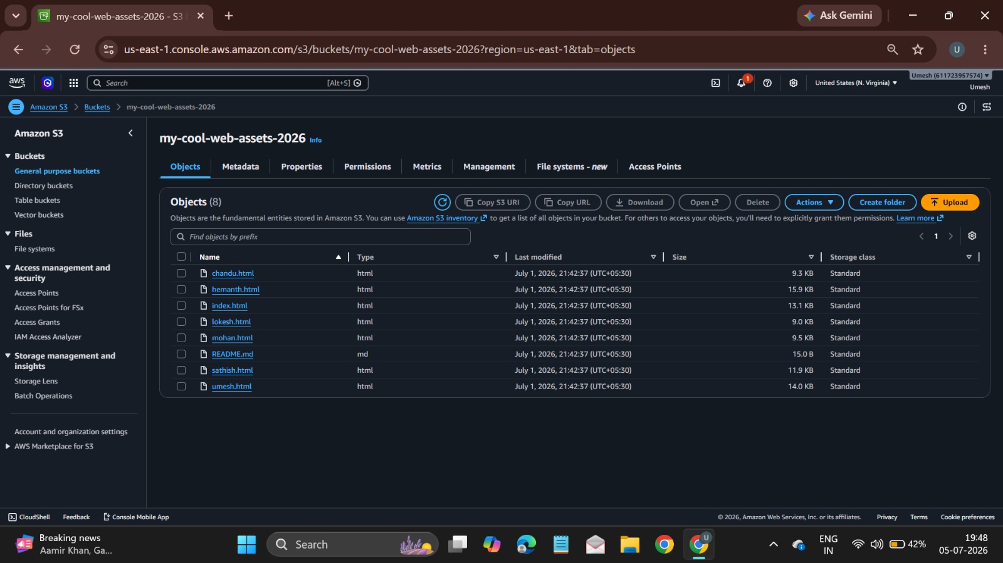
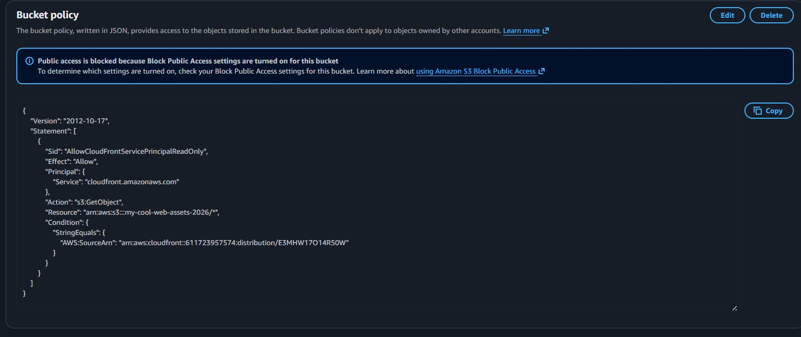

4.2 Distribution Layer - CloudFront
To achieve global low-latency delivery, Amazon CloudFront is implemented as the Content Delivery Network (CDN) layer. The distribution is configured with the S3 bucket as the origin, effectively offloading traffic from the storage layer. To ensure secure data transmission, HTTPS is enforced via an SSL/TLS certificate, protecting the integrity of the content as it travels to the end-user. Furthermore, custom caching policies are applied to optimize object delivery, ensuring that repeat visitors experience rapid load times due to assets being served from regional edge locations. [Figure 2: CloudFront distribution settings and origin configuration]
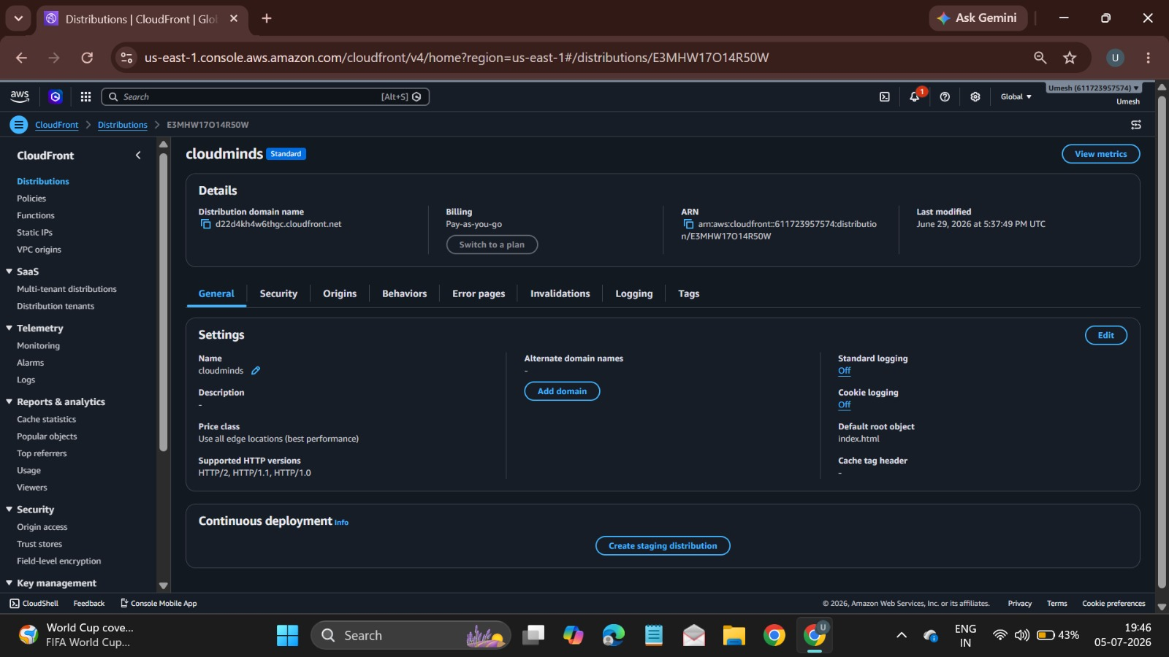

4.3 Security Layer - IAM
Security is maintained through AWS IAM (Identity and Access Management), which enforces the principle of least privilege across the entire architecture. IAM roles and policies are meticulously defined to govern the interaction between the CloudFront distribution and the S3 storage bucket. Specifically, the configuration restricts access so that content can only be retrieved through the authorized distribution, effectively mitigating the risk of unauthorized external access. By applying granular bucket policies, the infrastructure ensures that every service possesses only the minimum necessary permissions required to function. [Figure 3: IAM roles, OAC policies, and service trust relationships]


Monitoring Layer - CloudWatch + Alarms
The monitoring layer is powered by Amazon CloudWatch, which provides continuous observability of the system’s operational health. It is configured to track critical metrics such as request latency, total request counts, and HTTP error rates (4xx and 5xx). These metrics are essential for establishing a performance baseline. Furthermore, specific CloudWatch Alarms are configured to monitor for anomalies, such as a spike in error rates or potential site downtime. These alarms act as the proactive watchdog of the system, ensuring that performance degradation is detected immediately. [Figure 4: CloudWatch dashboard metrics and alarm threshold configurations]
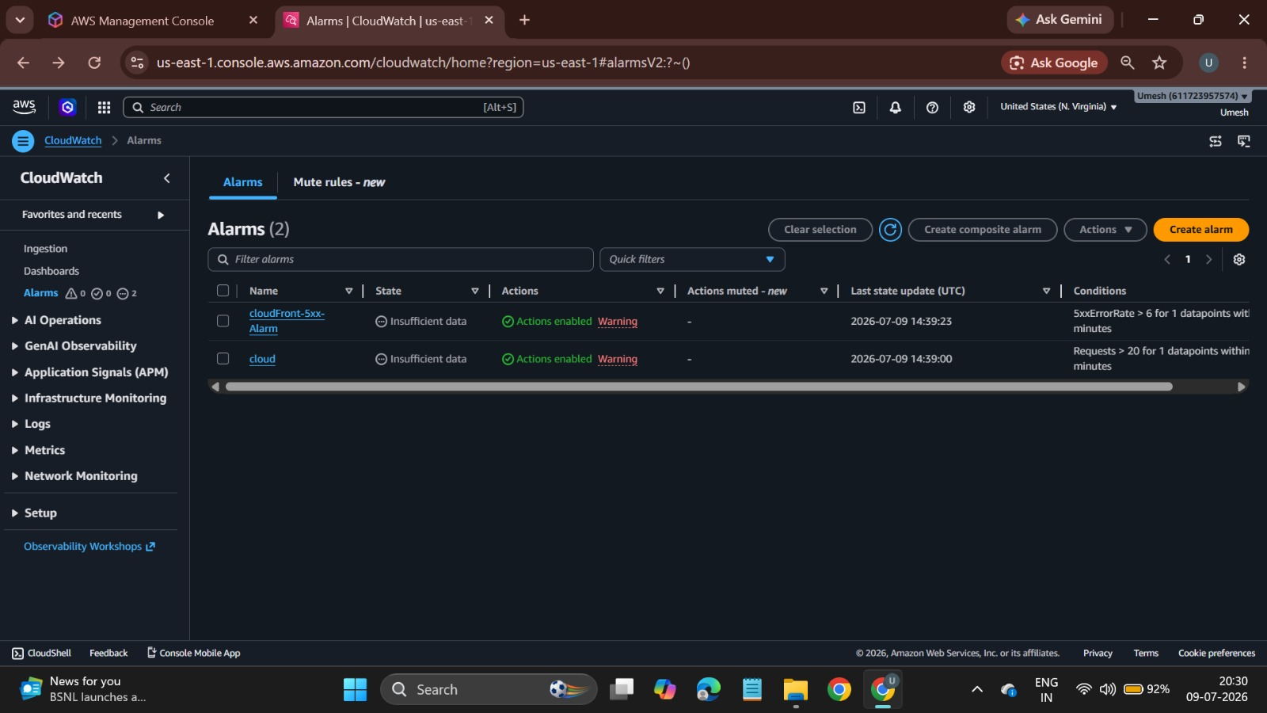

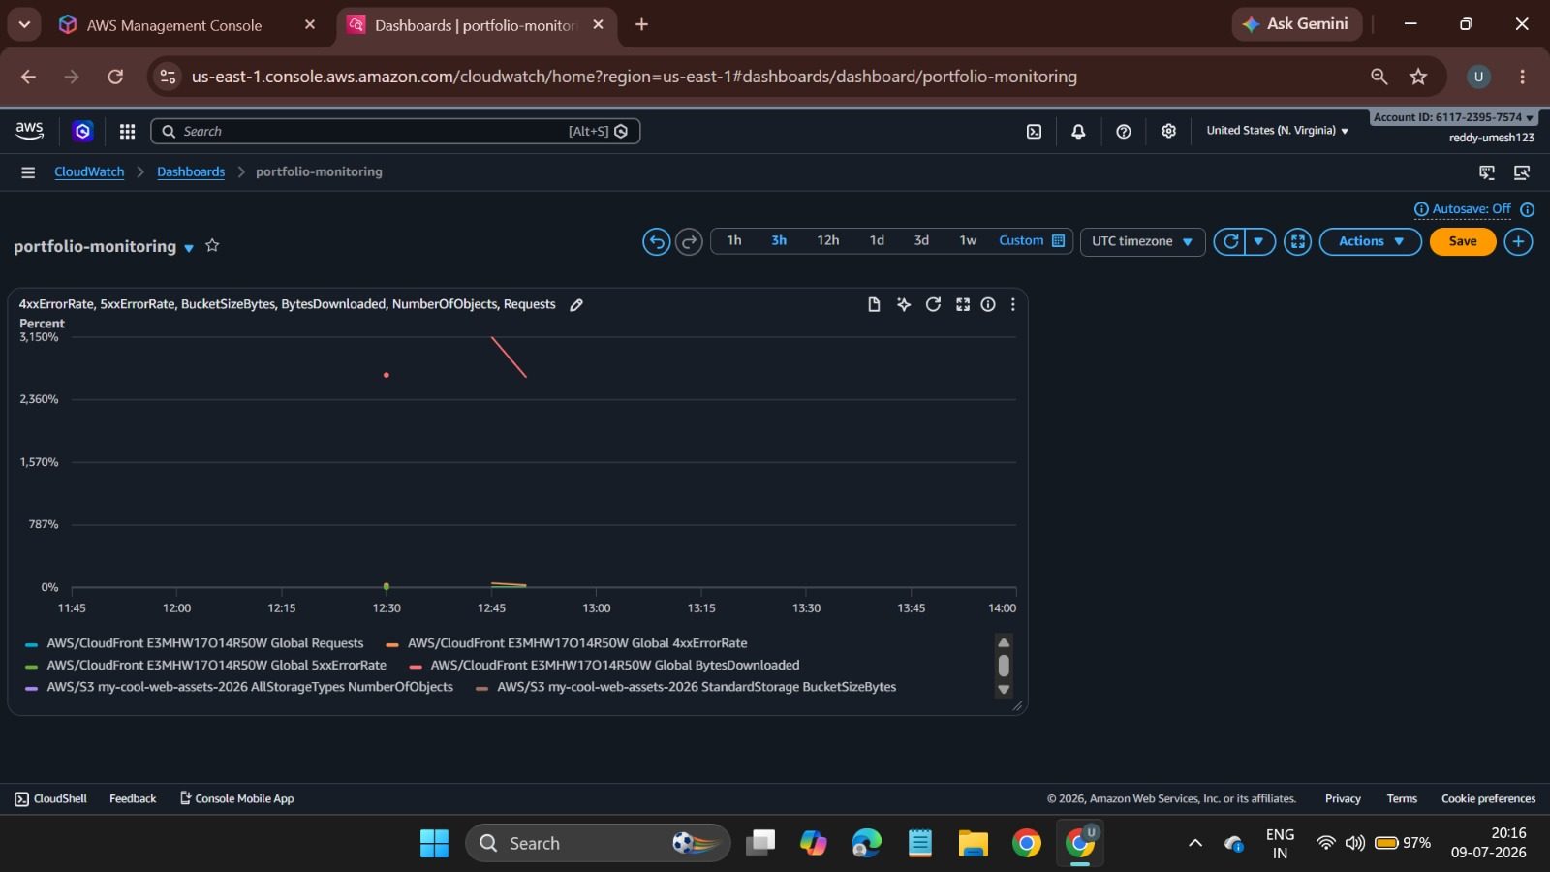

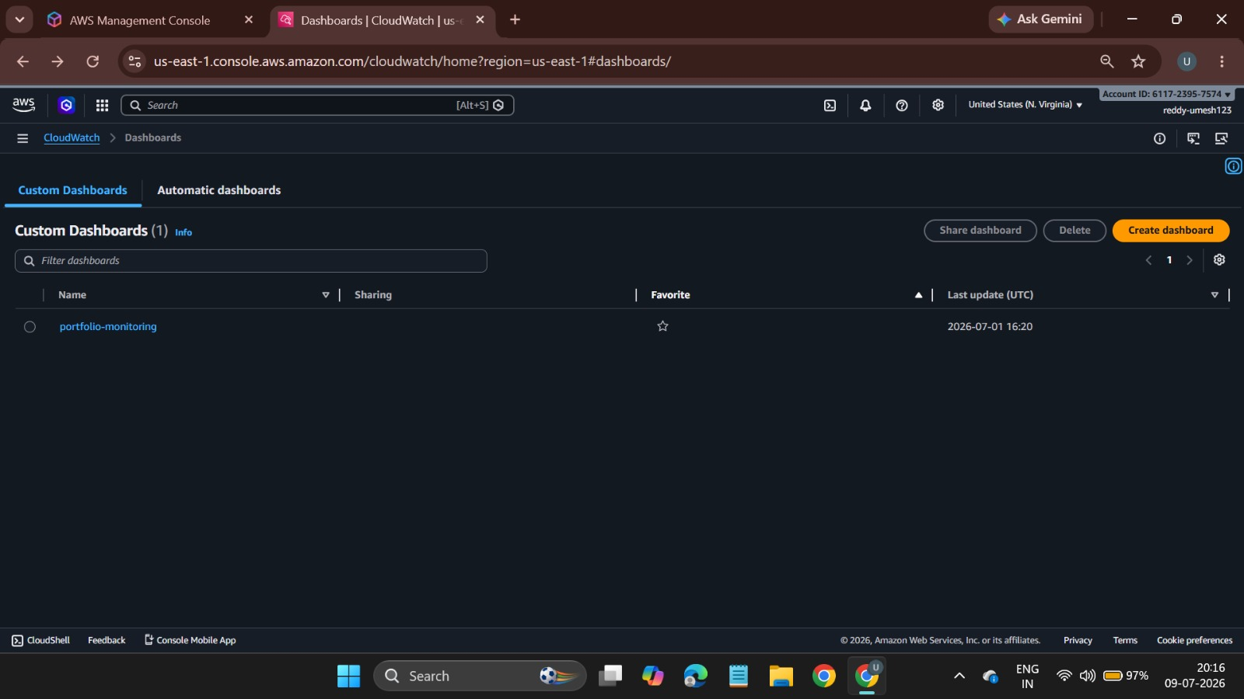

4.5 Notification Layer - SNS
The Amazon SNS (Simple Notification Service) acts as the final tier in the architectural stack, serving as the communication conduit for operational alerts. When a CloudWatch alarm enters an ALARM state, it triggers an event that is published to an SNS topic. This topic is configured to dispatch real-time email notifications to the site administrator. This automated notification loop ensures that the administrative team remains informed of the system's performance, facilitating rapid incident response and reinforcing the system's overall reliability. [Figure 5: SNS topic structure and email subscription workflow]
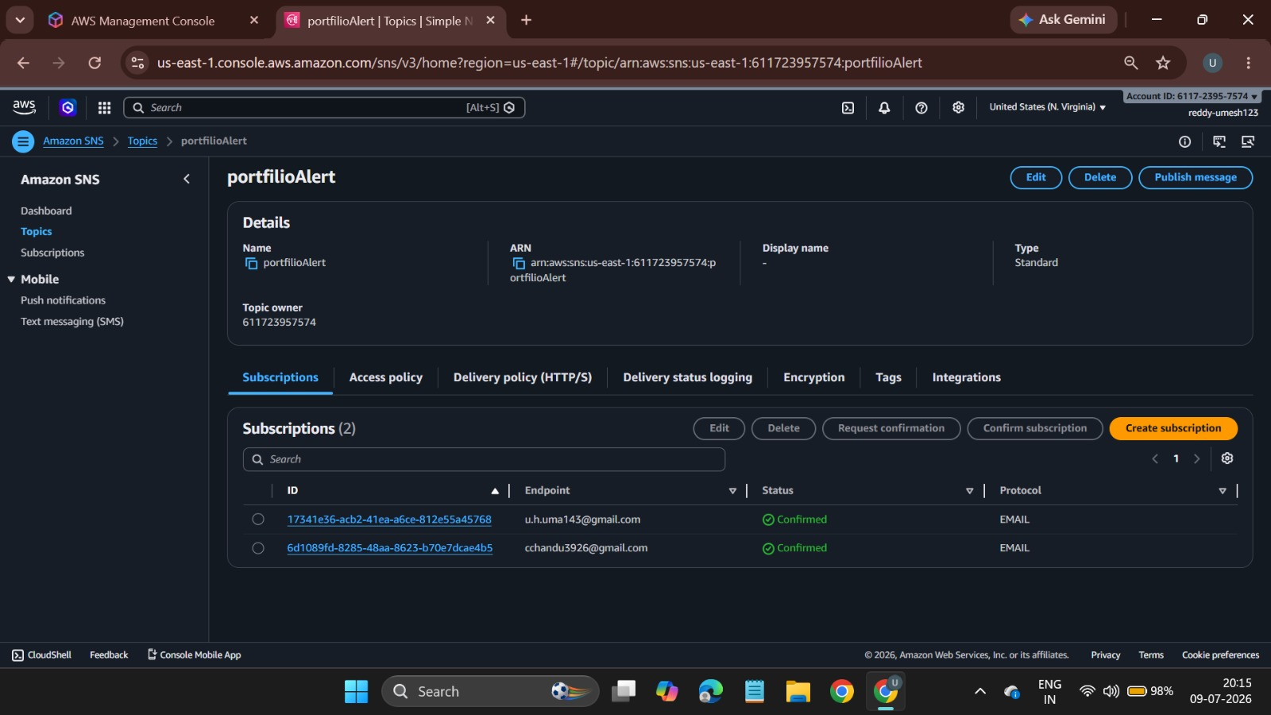

5. IMPLEMENTATION
The technical deployment of the static profile website was structured into five distinct phases, moving from initial asset provisioning to the configuration of a fully automated observability framework.

Phase 1: Storage Environment Initialization
1: Create a dedicated Amazon S3 bucket with a globally unique name.
2: Configure bucket settings to disable all public access to ensure security.
3: Disable static website hosting properties on the bucket.
.4: Synchronize local website files (HTML, CSS, JS) into the bucket root.

Phase 2: Content Distribution Deployment
1: Provision an Amazon CloudFront distribution.
2: Set the S3 bucket as the origin and enable Origin Access Control (OAC).
3: Configure SSL/TLS certificates via AWS Certificate Manager for HTTPS.
4: Define cache behaviors and TTL settings for optimal performance.

Phase 3: Security and Access Governance
1: Define IAM policies to manage service-to-service authentication.
2: Apply an OAC policy to the S3 bucket to allow only CloudFront access.
3: Use the principle of least privilege to restrict CI/CD deployment credentials.

Phase 4: Monitoring and Operational Alerting
1: Establish Amazon CloudWatch metrics for request latency and error rates.
2: Define threshold-based CloudWatch Alarms for 4xx/5xx errors.
3: Create an Amazon SNS topic to handle alert routing.
4: Subscribe the administrator email address to the SNS topic.

Phase 5: CI/CD Pipeline Automation
1: Configure GitHub Secrets to store encrypted AWS access credentials.
.2: Create a YAML-based workflow file in the .github/workflows/ directory.
3: Define the sync logic to push code to the S3 bucket upon a push to main.
4: Implement a final step in the script to trigger a CloudFront cache invalidation.

:6. RESULTS
The deployment of the static profile website using a serverless AWS architecture has successfully achieved the design objectives of high availability, enhanced security, and operational efficiency. The integrated system demonstrates a seamless workflow from automated code deployment to global content delivery and real-time monitoring.

6.1 Performance Outcome
The integration of Amazon CloudFront as the global content delivery network has provided a significant improvement in site accessibility. By caching static assets at edge locations, the website achieves sub-millisecond response times for global users. The transition to HTTPS, facilitated by the distribution layer, ensures that all user interactions are encrypted, meeting modern security compliance standards.

6.2 Security and Integrity Validation
The security posture of the infrastructure was validated by enforcing strict access boundaries. Through the use of Origin Access Control (OAC) and IAM policies, the origin Amazon S3 bucket is successfully shielded from the public internet. Test cases confirmed that any direct requests to the S3 bucket URL are rejected with a 403 Forbidden response, proving that the content is only retrievable via the authorized CloudFront distribution.

6.3 Operational Monitoring and Proactive Alerting
The monitoring framework provides real-time visibility into the infrastructure. Validation tests involving the simulation of HTTP 5xx errors confirmed that Amazon CloudWatch correctly identifies the anomaly within the configured five-minute evaluation window. Subsequently, Amazon SNS successfully dispatched an automated email notification to the administrative account. This confirms that the infrastructure is capable of self-reporting performance degradation, shifting maintenance from reactive to proactive.

6.4 Deployment Agility
The GitHub Actions CI/CD pipeline has successfully streamlined the development lifecycle. By automating the build, synchronization, and cache invalidation processes, the time required to propagate updates to the live site has been reduced to seconds. This automation removes the risk of manual deployment errors and ensures that the production environment consistently reflects the repository's state.

8. CONCLUSION
Hosting a static portfolio website using Amazon S3 and Amazon CloudFront provides a secure, scalable, highly available, and cost-effective solution for static website deployment. Amazon S3 is used to store and host the website’s static files, while Amazon CloudFront enhances performance by caching and delivering content through a global Content Delivery Network (CDN), resulting in faster page load times and reduced latency for users.
To maintain security and controlled access, AWS Identity and Access Management (IAM) is used to create users, roles, and policies that follow the principle of least privilege. Amazon CloudWatch continuously monitors the website and related AWS resources by collecting metrics and providing operational insights. CloudWatch Alarms are configured to monitor predefined thresholds and detect abnormal conditions. When an alarm is triggered, Amazon Simple Notification Service (SNS) sends email notifications to administrators, enabling prompt response to potential issues.
Overall, the integration of Amazon S3, Amazon CloudFront, IAM, Amazon CloudWatch, CloudWatch Alarms, and Amazon SNS provides a reliable, secure, high-performance, and well-monitored hosting solution for a static portfolio website. This architecture follows AWS best practices and ensures efficient website delivery, effective resource management, proactive monitoring, and timely alerting, making it an ideal solution for hosting modern static web applications.

